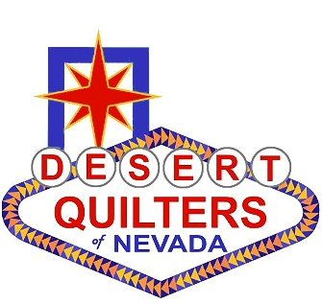
DESERT QUILTERS OF NEVADA
Membership Form 2018/19

Dues are $35 and include a Subscription to the Quilt Chatter. Renewals are due by September 30 for the following Oct. 1 to Sept. 30 membership year and are not prorated. PLEASE PRINT CLEARLY. You will receive your membership information via email. If you would like a paper copy of the information, please enclose a business size Self-Addressed Stamped Envelope. IF YOU WISH TO PAY BY CREDIT CARD, YOU MUST USE THE WEBSITE.

Name |  |  |  |  |  |  | New Member__ | Renewal __
Street |  |  |  |  |  |  | Youth/Student Member ___
City |  | State |  |  |  | Zip | Youth Member Sponsor:
Email Address: |  |  |  |  |  |  | _____________________________
Home Phone: |  |  |  | Cell |  |  | For Membership Committee Use
Birthday | MO |  | Day |  |  |  | Credit card ______
As a member of Desert Quilters of Nevada, the above information will appear in the Guild’s |  |  |  |  |  |  | Check #_________
directory. The information contained in the roster is not available for distribution or sale. |  |  |  |  |  |  | Cash $__________
* If you do not wish to receive emails from DQN, check here: ___
Photographs of you and/or your quilts may appear in the DQN newsletter and website. |  |  |  |  |  |  | Packet Processed Date: ___/___/___

ACTIVITIES AND OPPORTUNITIES TO SERVE
Volunteering, even a small amount of your time and/or talents, is a great way to become involved and meet more
Guild members. An indication of interest is not a commitment; however, your participation is encouraged.
COMMITTEES & ACTIVITIES |  | Talents in my “tool box”… don’t be shy!
___ Publicity | ___ Social Media | ___ Photoshop Elements, Corel Draw or other graphics program
___ Event Planning | ___ Telephone Calls | ___ Microsoft Excel or other spreadsheets
___ Organizing volunteers | ___ Teaching | ___ Microsoft Word or other word processors
___ Historian | ___ Programs (outside speakers) | ___ Microsoft Publisher or other publishing software
___ Photography | ___ Membership | ___ Website design or maintenance
___ Quilt Show Committee | ___ Retreat Committee | ___ Bookkeeping or accounting
___ CD Production | ___ Newsletter
___ Nominations | ___ Challenge | What workshops/speakers would you like to see the Guild offer?
___ Website | ___ Hospitality

YOU CAN RENEW YOUR MEMBERSHIP ONLINE BY PAYING WITH A CREDIT CARD.
Make your $35.00 check payable to: DESERT QUILTERS OF NEVADA
MAIL TO:
Hinde Socol, 2316 Snowy Moon Ct., Henderson, NV 89052
Questions? Contact Hinde at 702-462-2043 or hsocol27@gmail.com or visit www.dqnv.org

