Certificate of Participation

Your Name Here
I participated in the 2021 DQN Block of the Month project – “Waiting for the Vaccine.”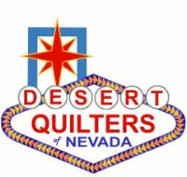
GREAT JOB!
Christine, Linda, Jeanne, Nannett, and Patsy

