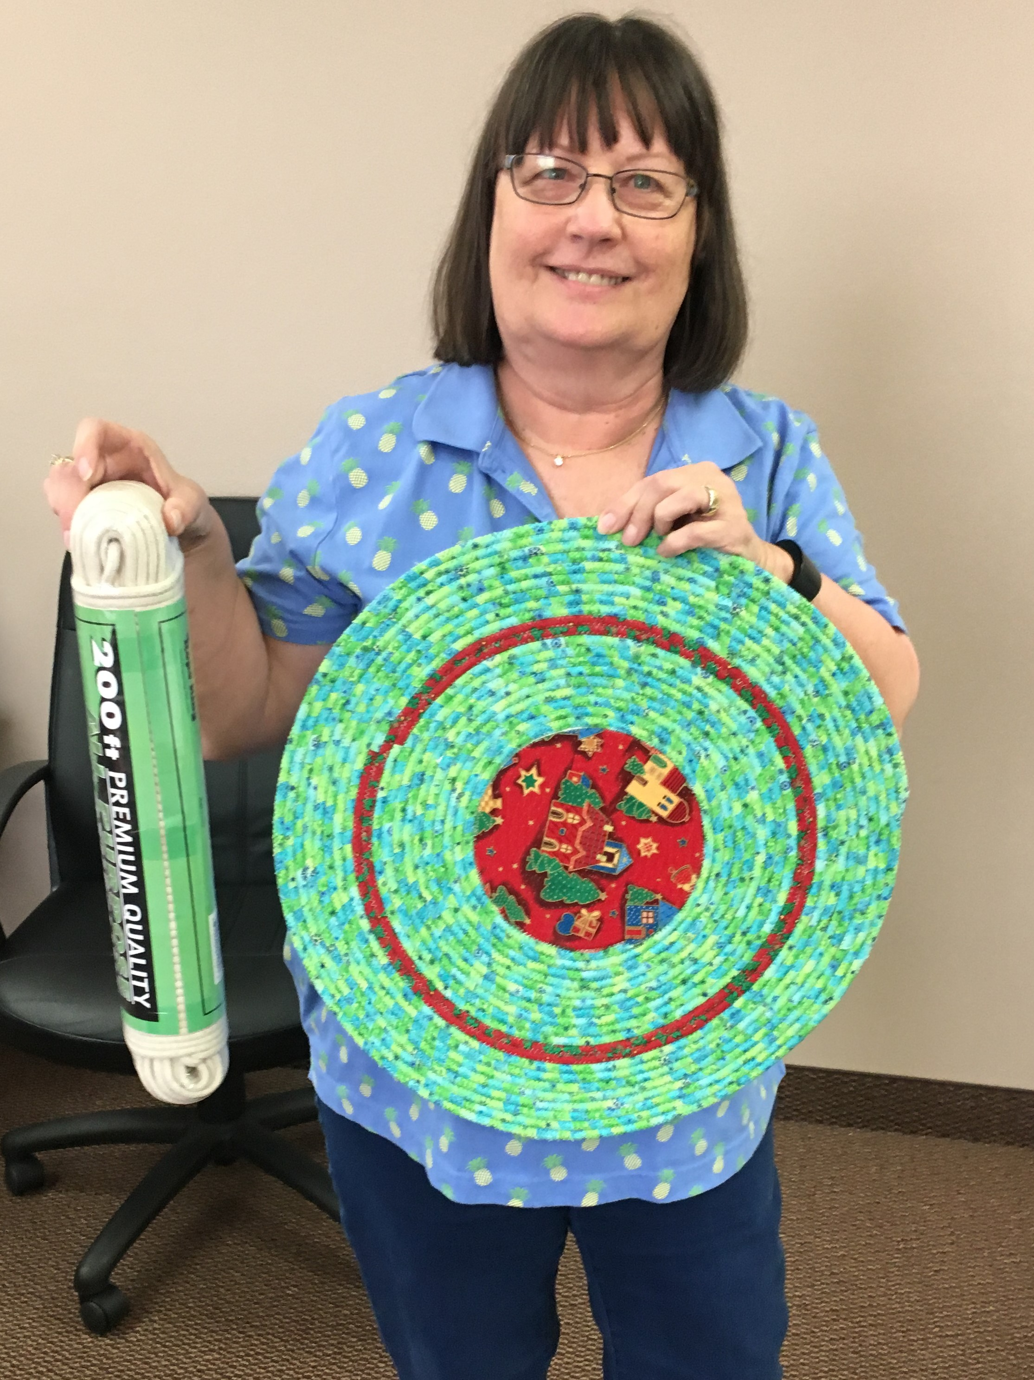DESERT QUILTERS OF NEVADA presents: 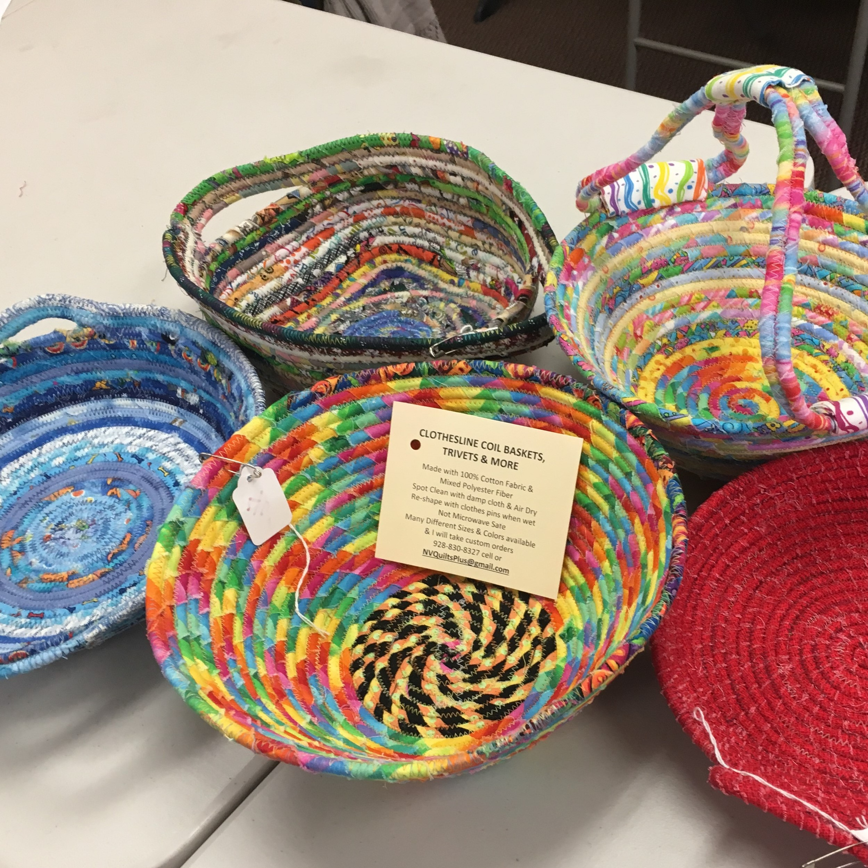

QUILT TIL U WILT 2018
CLOTHESLINE BASKETS etc.

Denice Heitkamp, DQN member of Green Valley Quilters &Loose Threads, will be teaching us all you need to know to make successful, beautiful fabric baskets, table toppers, trivets, keychains, totes or microwave baskets. She will be providing the basic supplies including her preferred clothesline for your project in the Kit for this fun time.

QTUW July 14, 2018
Henderson Convention Center 9:30 am-4:30 pm
200 South Water Street Henderson, NV 89015

Name_____________________________________________________________________________________________

Email____________________________________________________________

Home or Cell Phone ______________________________

Saturday, July 14, 2018: Fabric Baskets ………………………….$45.00_______________________

Kit Fee (required): ……………………………………………………………$ 7.00_______________________

Member discount (coupon must be enclosed) . . . . . . … $10 discount ____________________

Nonmembers welcome space permitting additional $10.00 fee per class
……………………………………………………………………………………..…… $10 ________________________

Total Enclosed . . . . . . . . . . . . . . . . . . . . . . . . . . . . . . . . . . . . . . . . . . . . . . . . . .$ ____________________

Registration fees are non-refundable, unless your spot is filled by someone else.
Doors open at 9am for set-up; class starts promptly at 9:30 am. Questions? Please contact Jeanne Spala, jspala@cox.net, 702-290-1373 (cell). Make checks payable to DESERT QUILTERS OF NEVADA and send with registration form to: Jeanne Spala, 4458 Via Bianca Avenue, Las Vegas, NV 89141.

