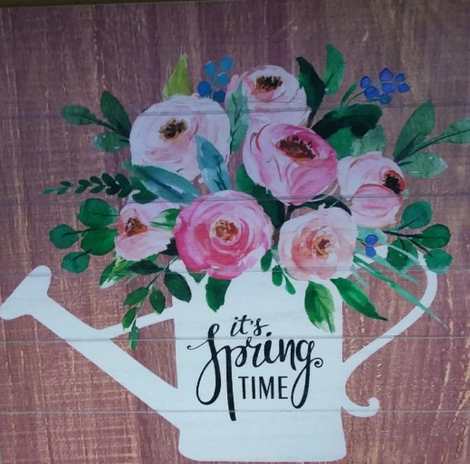

Monday, March 23rd
Independence Hall, Nelson Room
10:00 a.m. until 2:00 p.m. (for SCA Sewing Club members)
11:30 a.m. until 2:00 p.m. (for SCA community and guests)

Everything to do with sewing will be for sale including fabric, precut fabric, patterns, kits, books, rulers, notions and much more. Bring your stash of cash or checks!

Meet your neighbors, enjoy refreshments, and shop for those items you just cannot resist! A special raffle will be available for a GORGEOUS spring quilt. Raffle prizes will be given away every hour, AND you don't even have to be present to win. Tickets for raffle prizes will be sold at the door.

Sponsored by Sun City Anthem Sewing and Quilting Club's Loose Threads.

